**Author:** Susie Kuo

**Date:** 11/14/17

**Contact:** 650-823-3216, [susan_kuo@hms.harvard.edu](mailto:susan_kuo@hms.harvard.edu)

**InfoSAGE provider content page**

* **Intent:** Create a website for providers to upload informative content for InfoSAGE users.
* **Technical specs:** Angular JS, PHP for front-end web app; Apache server; MySQL db
* **Development process:** Environment was implemented by MAMP.
* **Files:** 
  + index.php
  + insert.php
  + display.php
  + delete.php
  + test.mysql
* **index.php** 
  + Creates the web page where users can type in dedicated fields to create, update, or delete a record, as well as view a table of all current records. The embedded HTML editor is TextAngular JS.
  + Calls insert.php to create and update mysql table “infosage” in database “test”
  + Calls display.php to populate a table of all current records.
  + Calls delete.php to delete a record from the table on the page as well as from the mysql table.

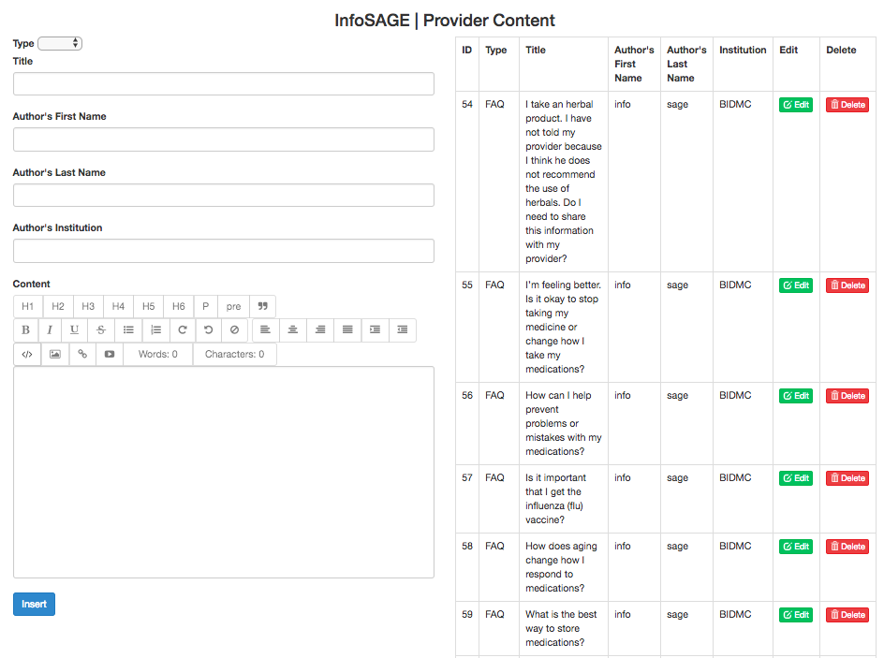

* **infosage.sql**
  + Table structure pre-populated with FAQ data from Darren resides here.
  + The PHP scripts access the mysql table as user “bidmc” password “” (i.e. no password). This is of course easily changed in PHP scripts. You will need to modify insert.php, display.php, and delete.php.

